Q1:

CODE:

#include<stdio.h>

#include<iostream>

#include<sys/types.h>

#include<unistd.h>

#include<sys/wait.h>

using namespace std;

int main()

{

int val2=fork();

int val=fork();

for(int i=0;i<2;i++)

{

if(val==0 || val2==0)

{

cout<<"child id is:"<<getpid()<<" "<<"parent id is:"<<getppid()<<endl;

}

else if(val>0||val2>0)

{

//cout<<" "<<"parent id is:"<<getppid()<<endl;

}

}

return 0;

}

SCREENSHOT:

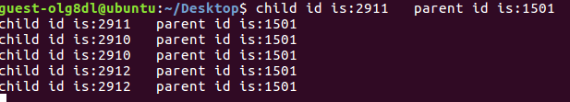

Q2:

(a):

CODE:

#include<iostream>

#include<sys/types.h>

#include<sys/wait.h>

#include<unistd.h>

#include<stdio.h>

using namespace std;

int main()

{

cout<< execl("/bin/ls","/bin/ls","-lh","/home",NULL)<<endl;

return 0;

}

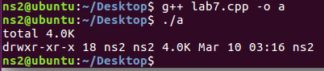

(b):

Code:

#include<iostream>

#include<sys/types.h>

#include<sys/wait.h>

#include<unistd.h>

#include<stdio.h>

using namespace std;

int main()

{

cout<< execlp("/bin/ls","-lh","/home",NULL)<<endl;

return 0;

}

Screenshot:

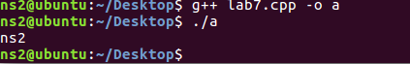

(c):

CODE:

#include<iostream>

#include<sys/types.h>

#include<sys/wait.h>

#include<unistd.h>

#include<stdio.h>

using namespace std;

int main()

{

char \*p="/bin/ls";

char \*arg[]={p,"-lh","/home",NULL};

cout<< execv(p,arg)<<endl;

return 0;

}

Screenshot:  
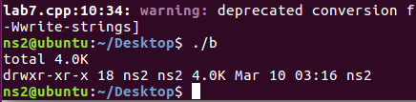

(d):

CODE:

#include<iostream>

#include<sys/types.h>

#include<sys/wait.h>

#include<unistd.h>

#include<stdio.h>

using namespace std;

int main()

{

char \*p="ls";

char \*arg[]={p,"-lh","/home",NULL};

cout<< execv(p,arg)<<endl;

return 0;

}

Screenshot:  
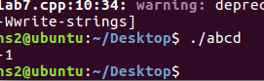

( e ):  
code:

#include<iostream>

#include<sys/types.h>

#include<sys/wait.h>

#include<unistd.h>

#include<stdio.h>

using namespace std;

int main()

{

char \*p="/bin/bash";

char \*arg1="-c";

char \*arg2="echo visit $HOSTNAME:$PORT from your browser.";

char \*const env[]={"HOSTNAME=www.linuxhint.com","PORT=8080",NULL};

fork();

execle(p,p,arg1,arg2,NULL,env);

return 0;

}

SCREENSHOT:  
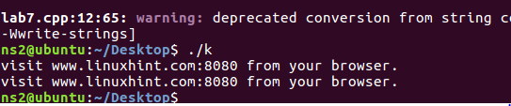

(f):

CODE:

#include<iostream>

#include<sys/types.h>

#include<sys/wait.h>

#include<unistd.h>

#include<stdio.h>

using namespace std;

int main()

{

char \*p="/bin/bash";

//char \*arg1="-c";

char \*arg[]={"/bin/bash","-c","echo visit $HOSTNAME:$PORT from your browser."};

char \*const env[]={"HOSTNAME=www.linuxhint.com","PORT=8080",NULL};

execve(p,arg,env);

return 0;

}

SCREENSHOT:

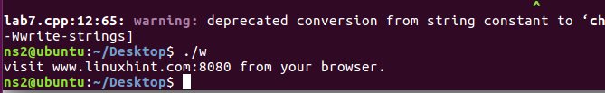

Q3:

CODE:

EXAMPLE.CPP:

#include<iostream>

#include<sys/types.h>

#include<sys/wait.h>

#include<unistd.h>

#include<stdio.h>

using namespace std;

int main()

{

int val=fork();

if(val==0)

{

execl("/hello.cpp","/hello.cpp","-c","/Desktop",NULL);

}

cout<<"pid of example.cpp "<<getpid()<<endl;

return 0;

}

HELLO.CPP:

CODE:

#include<iostream>

#include<sys/types.h>

#include<sys/wait.h>

#include<unistd.h>

#include<stdio.h>

using namespace std;

int main()

{

//execl("/example.cpp","/example.cpp","-c","/Desktop",NULL);

fork();

cout<<"we are in hello.cpp"<<endl;

cout<<"pid of hello.cpp "<<getppid()<<endl;

//cout<<"pid of hello.cpp "<<getpid()<<endl;

return 0;

}

SCREENSHOT:  
